PGE 392K In Class Problem

Nov 19, 2020

1. When you have completed the assignment from Nov 17 and verified the solution, copy all of your files from Nov 17 into a new folder for Nov 19
2. Change your input file to NX =50; NY=1 and t = 10 days and run your code. Make plots the following plots:
   1. Sw versus xD at tD =0.2, 0.5, 0.8. Recall the dimensionless distance and time (pore volumes injected), xD=x/L and tD= qt/(V*f)
   2. Water cut (%) of the producer versus time. To calculate water cut, use the fractional flow equation in the grid block



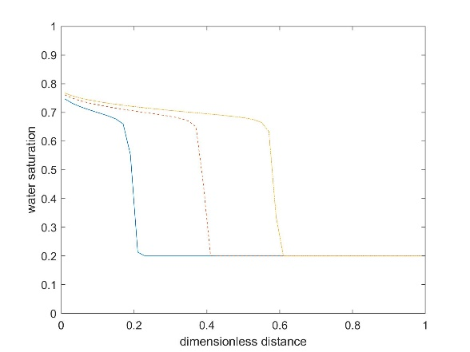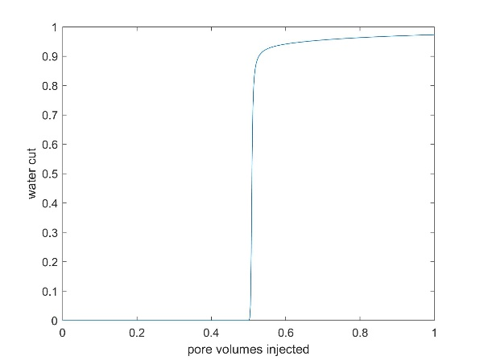

1. Repeat #2a but use Nx=20, 100, and 200 grids. How does the solution change?
2. Adapt your code to include constant BHP wells
   1. In your function file/subroutine to compute productivity index (J), adapt it so that it comes phase indexes Jw and Jo. Be sure to change the outputs and inouts (ti include petrophysical properties and Sw
   2. In your function file/subroutine to “update wells” to adapt your code to calculate Jw, J, Qw, and Qo arrays for multiphase flow.
   3. You will need to also compute an overall J either in updatewells or your main code.
3. Copy your 1D input file and rename it inputfile_2D. Verify the code against the the NX =3; NY=3 example in the provided powerpoint document. Be sure that all the inputs match. Verify your solution by viewing the To, Jo, Qw, Q, and D arrays at time 0. Then verify pressure and water saturation at early (1,2,3 days) and late times (500 days).